
Jira

Jira is a project management and issue-tracking tool used by teams to plan, track, assign, and manage work throughout the software development lifecycle.
It helps teams organize work into items such as Epics, Stories, Tasks, and Bugs, assign them to team members, track progress using workflows (To do, in progress, done) and ensure timely delivery.
Jira is widely used by Product, Development, QA, and DevOps teams to collaborate efficiently, maintain transparency, and improve project visibility.

Following are the steps to proceed using JIRA:
- Login and go to home page

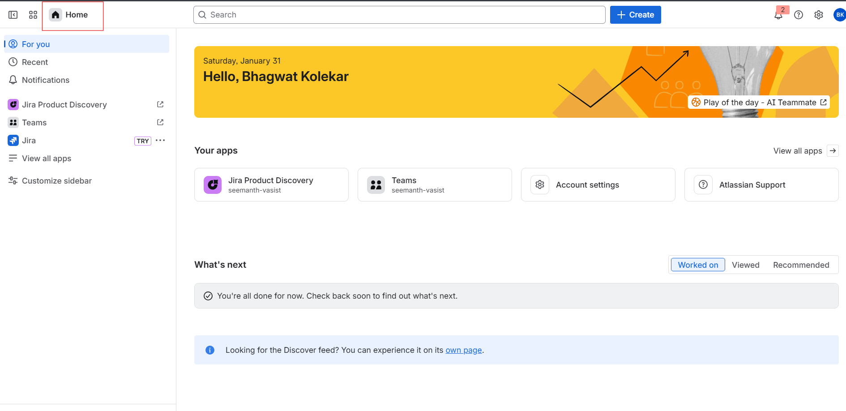

- To create new task click on “Create”

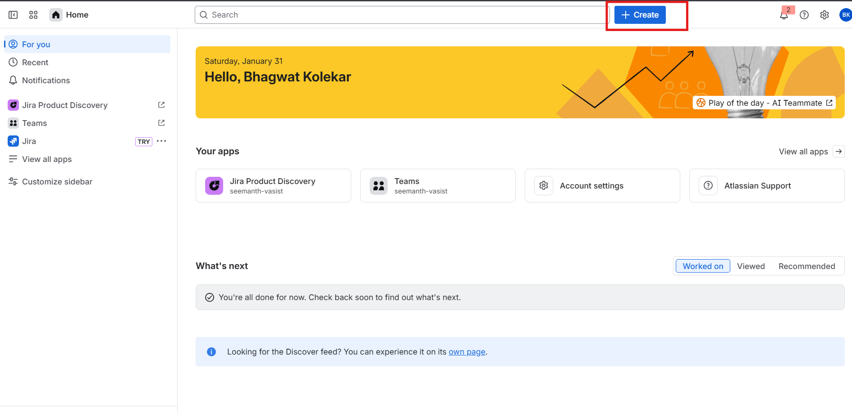

- Add Space and work type and also mention status of task

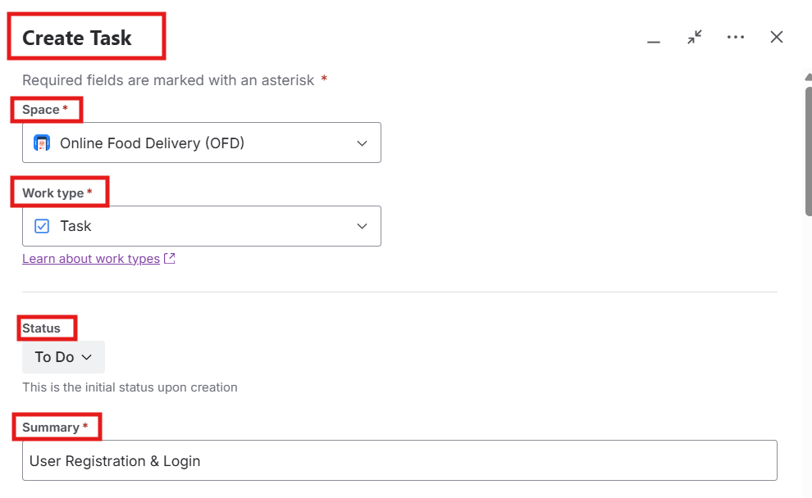

- Add Description of task, assign task to team member and task reporter, Priority

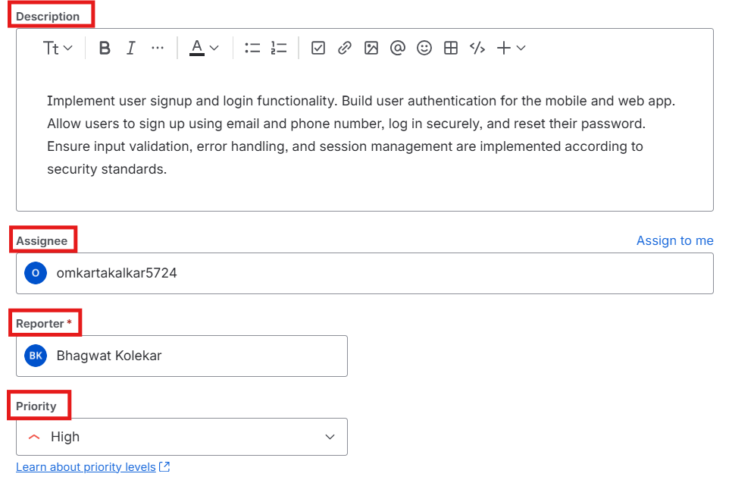

- Add start and end date for task and also add files for task if required

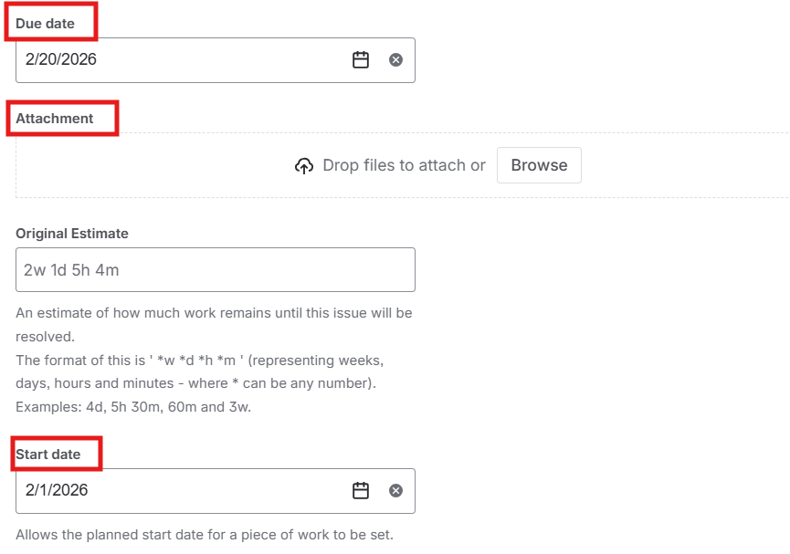

- Mention Team and Budget of task, then click on create

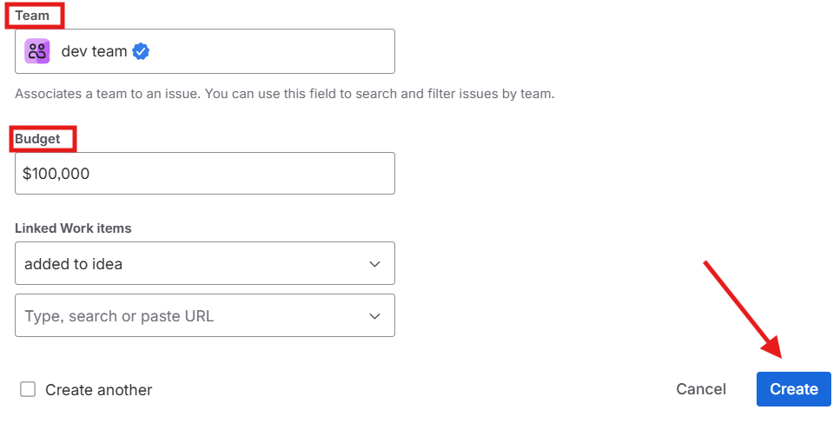

- Add comment and reply to comment

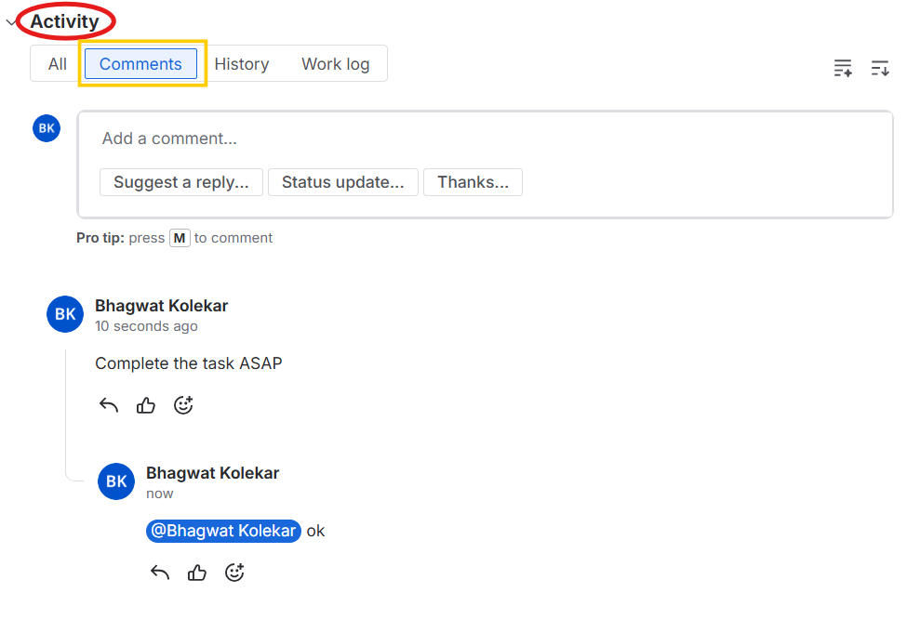

- Workstorm

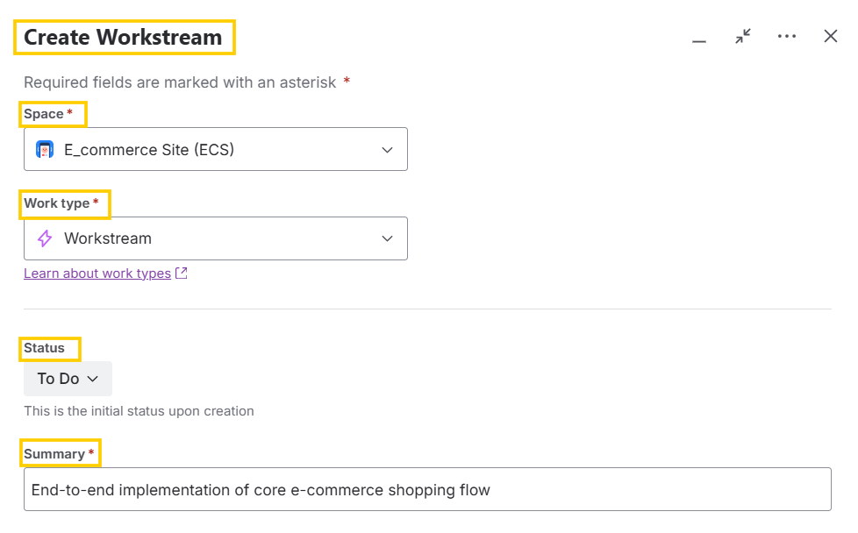
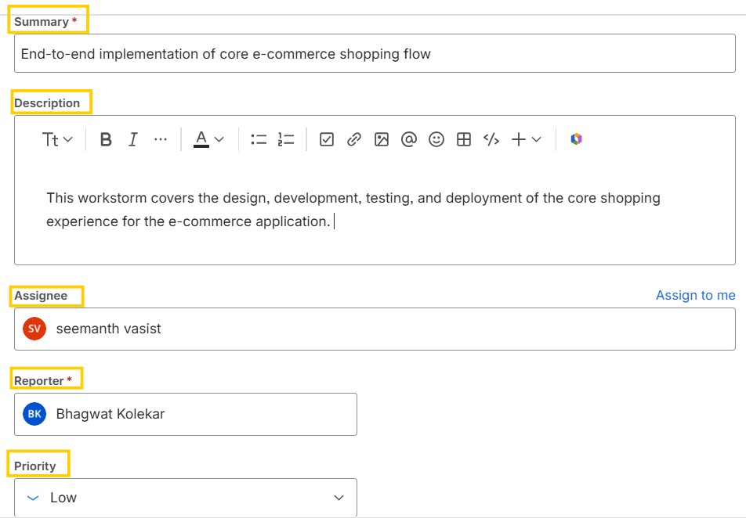

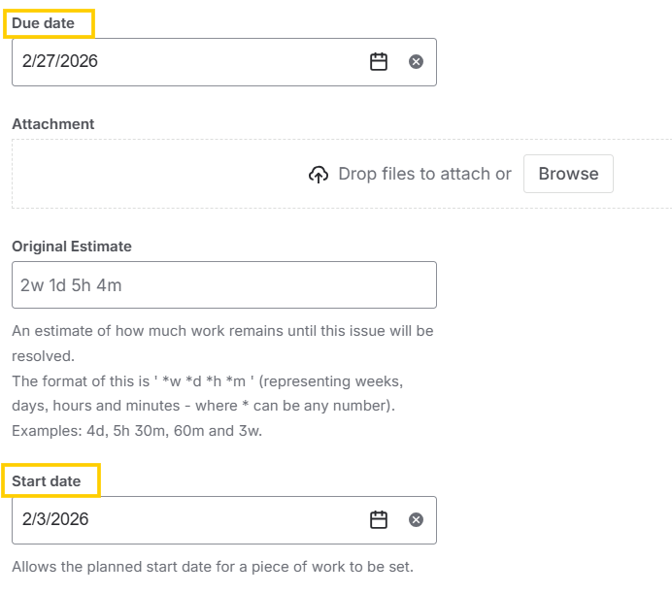

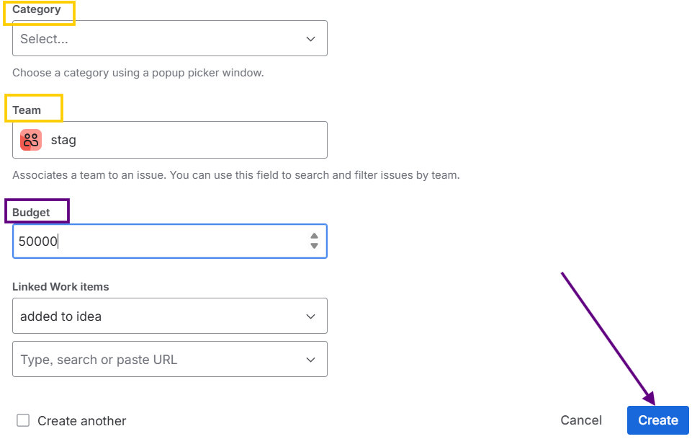

After creating the tickets, the results will be as shown:

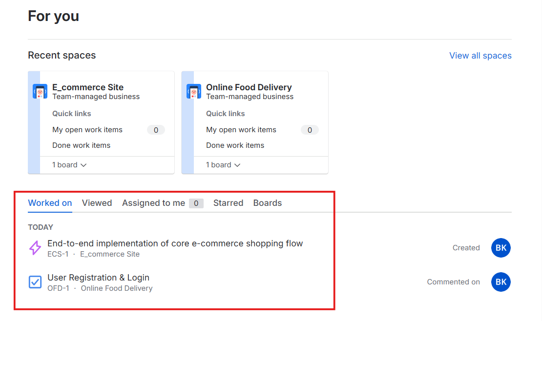

JIRA TASK PROGRESS

Move tasks from To DO

In Progress, Review and Done by using dragging method

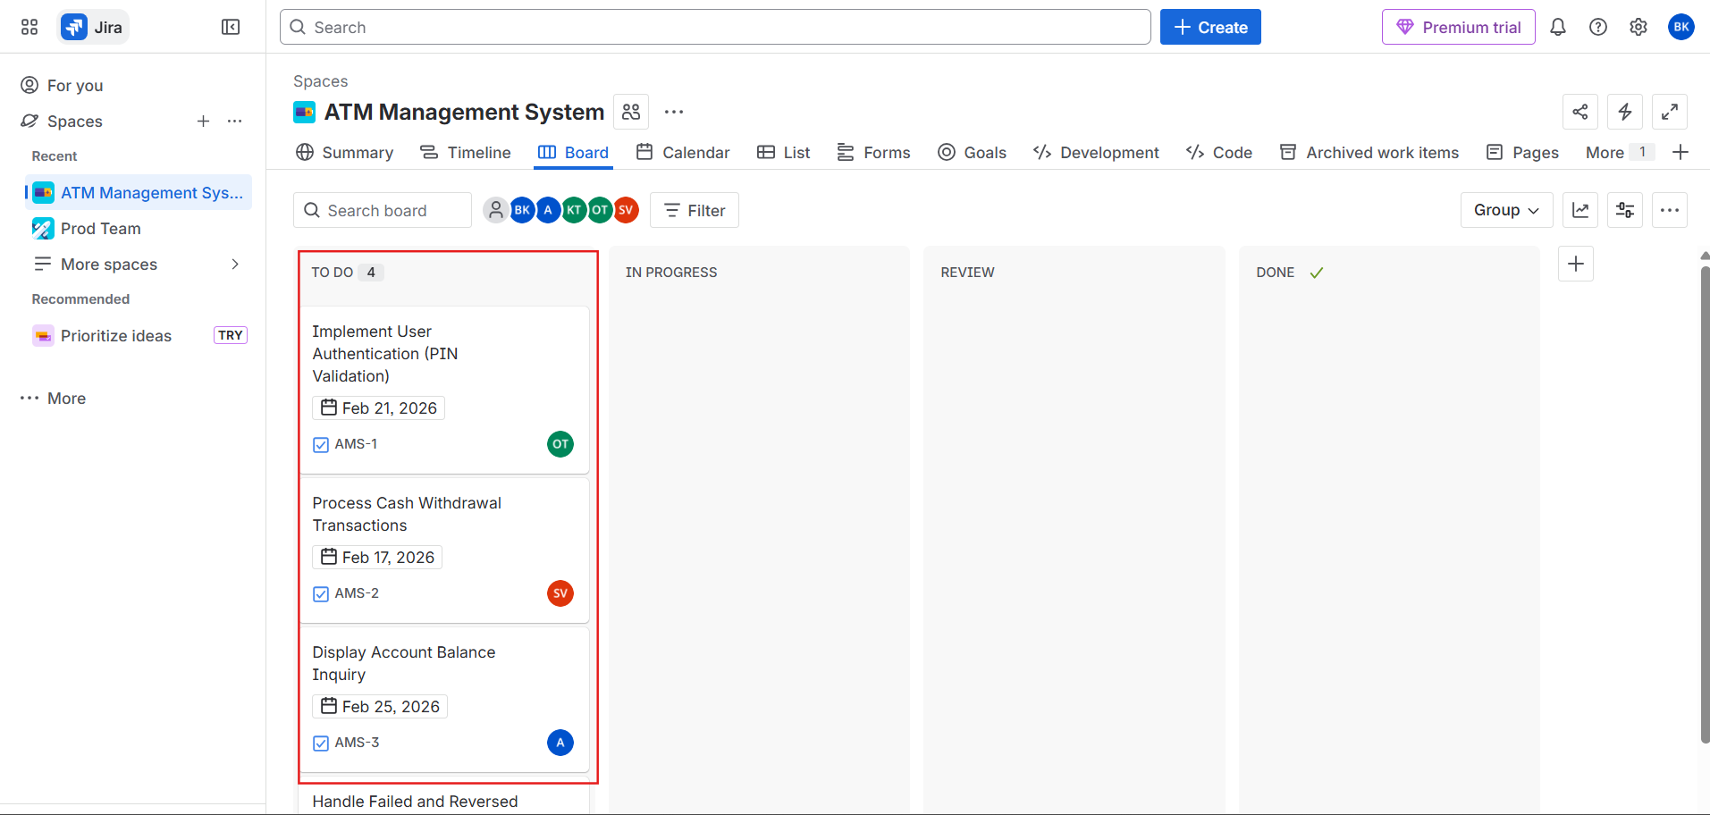

To Do → In Progress
When a task is ready to be worked on, it is dragged from the To Do column to the In Progress column. This indicates that the team has started working on the task.

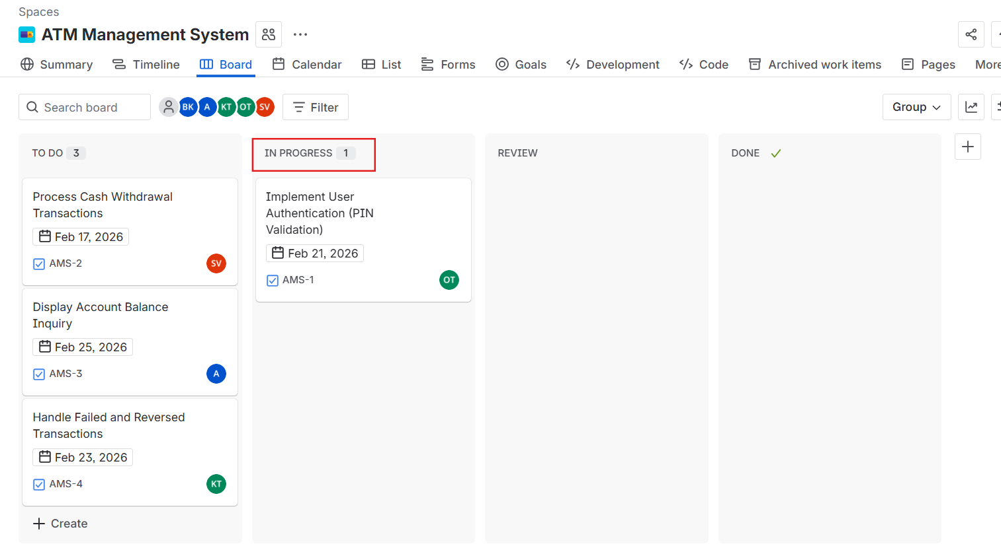

In Progress → Review
After the work on the task is completed, the task is dragged to the Review column. This shows that the task is waiting for verification, testing, or approval before completion.

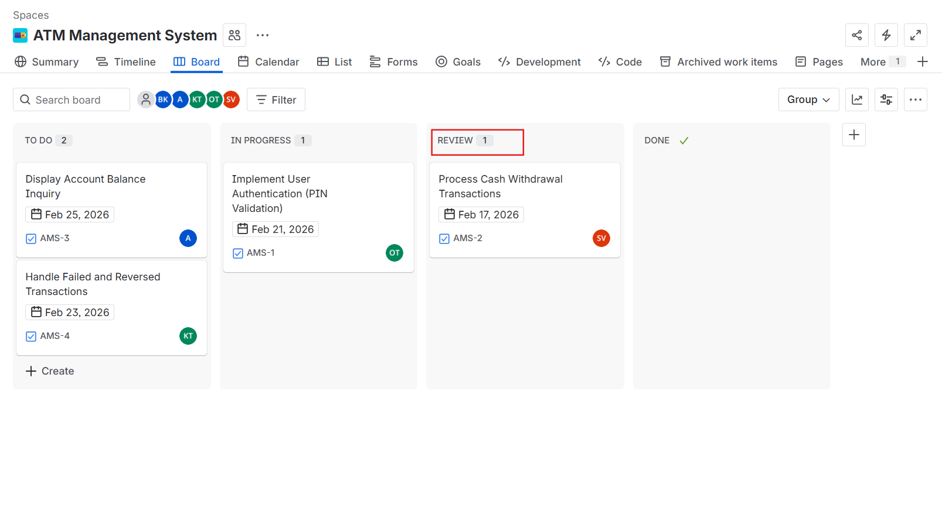

Review → Done
Once the task passes review and meets all requirements, it is dragged to the Done column. This means the task is fully completed and no further action is required.

